SIPRI (Software for Identification & Planning of Rural Infrastructure)
User Manual
SIPRI Integration with Anushravan Module
For Gram Panchayat (GP) and Sub Engineer (SE) Users
Mobile Application and Web Portal
Govt. of Madhya Pradesh
Version 1.2 | October 2026

Madhya Pradesh State Electronics Development Center (MPS@DC)
State IT Center, 47-A, Arera Hills, Bhopal, M.P. – 462011,
Phone: +91-755-2518300,
Fax: +91-755-2579824
URL: www.mpsedc.mp.gov.in

Table of Contents
Contents
1. Overview / अवलोकन 3
2. Installation / स्थापना 4
3. Login using Mobile Number and OTP / मोबाइल नंबर और OTP से लॉगिन 4
4. Dashboard and Language Selection / डैशबोर्ड और भाषा चयन 5
5. GP Login: Raise a New RFI / GP लॉगिन: नया RFI दर्ज करें 6
6. GP Login: View RFI History / GP लॉगिन: RFI इतिहास देखें 9
7. Sub Engineer (SE) Login: Inspect and Accept / Reject RFI / SE लॉगिन: RFI का निरीक्षण और स्वीकृत / अस्वीकृत करें 10
8. Sub Engineer (SE) Login: View RFI History / SE लॉगिन: RFI इतिहास देखें 14
9. SE User Management: Create and Edit Users / SE उपयोगकर्ता प्रबंधन: उपयोगकर्ता बनाना और संपादित करना 16
10. Web Portal: Anushravan GP Report / वेब पोर्टल: अनुश्रवण GP रिपोर्ट 17
11. Important Notes / महत्वपूर्ण बिंदु 18

1. Overview / अवलोकन
The SIPRI – Anushravan GP module helps a Gram Panchayat (GP) request a site inspection and helps a Sub Engineer (SE) inspect the site and give the decision. The department can see all RFIs in the web report.
Who uses the module
User | What the user does
GP User (Anushravan) | Logs in to the SIPRI mobile app, raises an RFI for a work site and checks the RFI History.
Sub Engineer (SE) | Logs in to the SIPRI mobile app, inspects the site and Accepts (Approves) or Rejects the RFI.
District Admin | Logs in to the SIPRI web portal and creates or edits users with the Anushravan category.
Web User | Logs in to the web portal and views the Anushravan GP Report.
How it works
- The Gram Panchayat downloads the SIPRI app.
- The GP logs in and raises an RFI.
- The Sub Engineer is assigned to that GP.
- The Sub Engineer does the inspection and accepts or rejects the RFI.
RFI status
Status | Meaning
Pending | The RFI is raised by the GP. The inspection by the Sub Engineer is not done yet.
Approved | The Sub Engineer inspected the site and accepted the RFI.
Rejected | The Sub Engineer inspected the site and rejected the RFI.

2. Installation / स्थापना
Step 1: Install the app
- Open the Google Play Store on your mobile.
- Search for the "SIPRI (MP)" app.
- Tap Install and wait for the installation to complete.
Step 2: Open the app
- Tap the SIPRI app icon to open it.
- When the app asks for location permission, tap Allow (While using the app). Keep the location (GPS) ON.

3. Login using Mobile Number and OTP / मोबाइल नंबर और OTP से लॉगिन
GP and SE users log in in the same way.
Note for GP users: Before using the mobile app, the GP user must log in once to the SIPRI web portal using the Panchayat Darpan login credentials (see Section 10 and Section 11).
- Step 1: Enter your registered 10-digit mobile number and tap OTP भेजें (Send OTP).
- Step 2: The message "OTP Sent successfully" appears. Tap ठीक है (OK).
- Step 3: Enter the OTP received on your mobile and tap लॉगिन (Login).
- Step 4: The message "Welcome" appears. Tap ठीक है (OK). The dashboard opens.

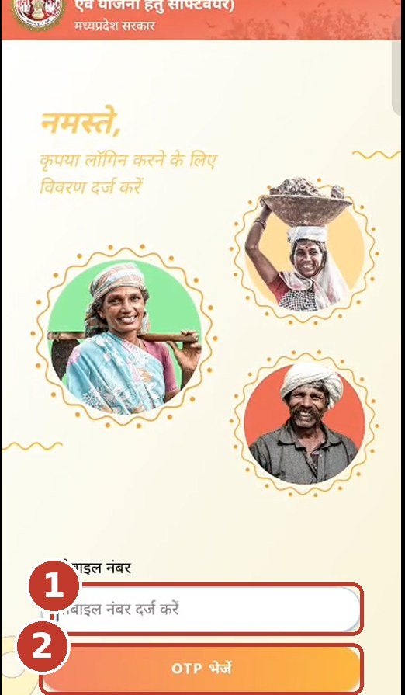  (1) Enter mobile number  (2) Tap OTP भेजें | 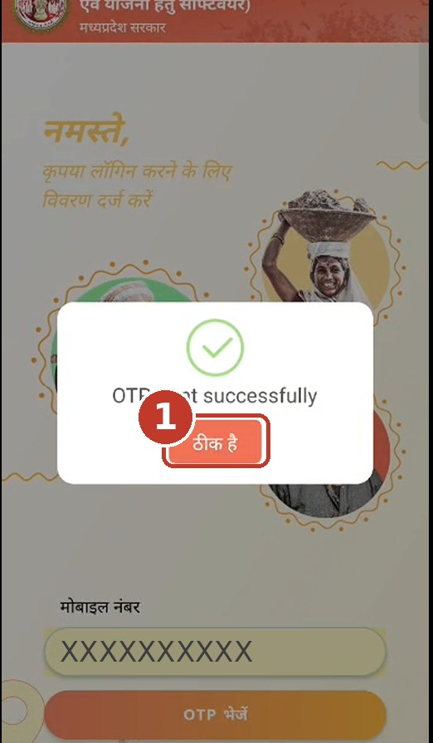  (1) Tap ठीक है (OK) | 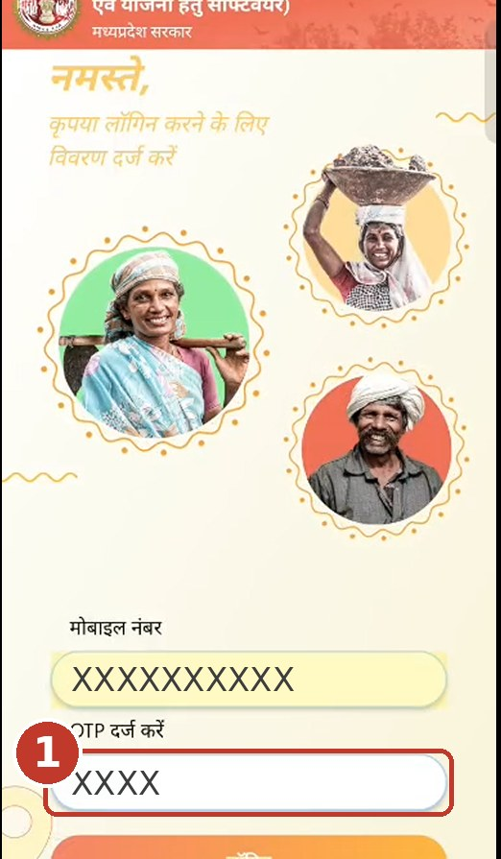  (1) Enter OTP and tap Login | 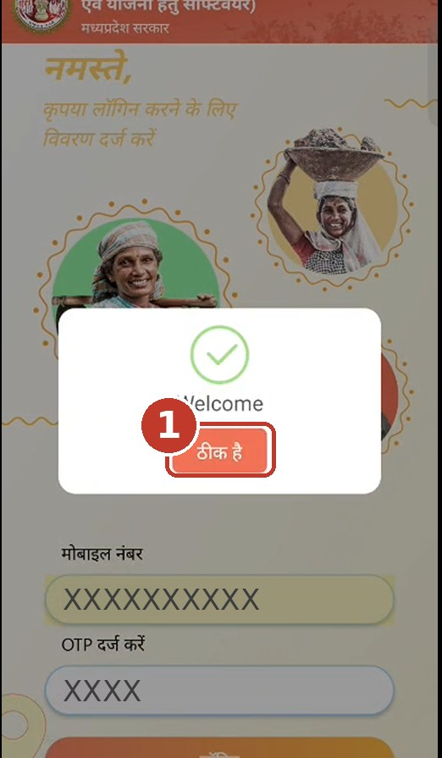  (1) Tap ठीक है (OK)

4. Dashboard and Language Selection / डैशबोर्ड और भाषा चयन
Step 1: Open the module
- After login, the dashboard opens. Tap ANUSHRAVAN to open the module.
Step 2: Change the language (optional)
- Tap the three dots (⋮) at the top right of the dashboard and choose Select Language.
- Tap English or Hindi.

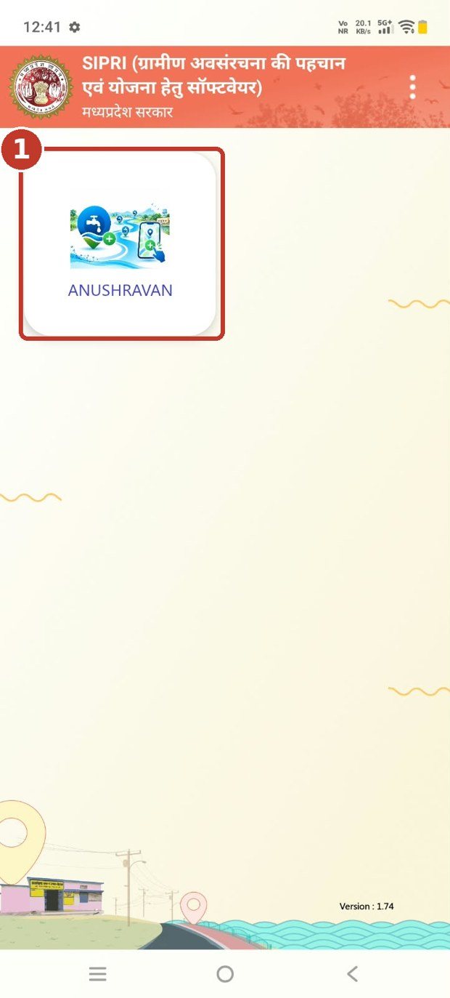  (1) Tap ANUSHRAVAN | 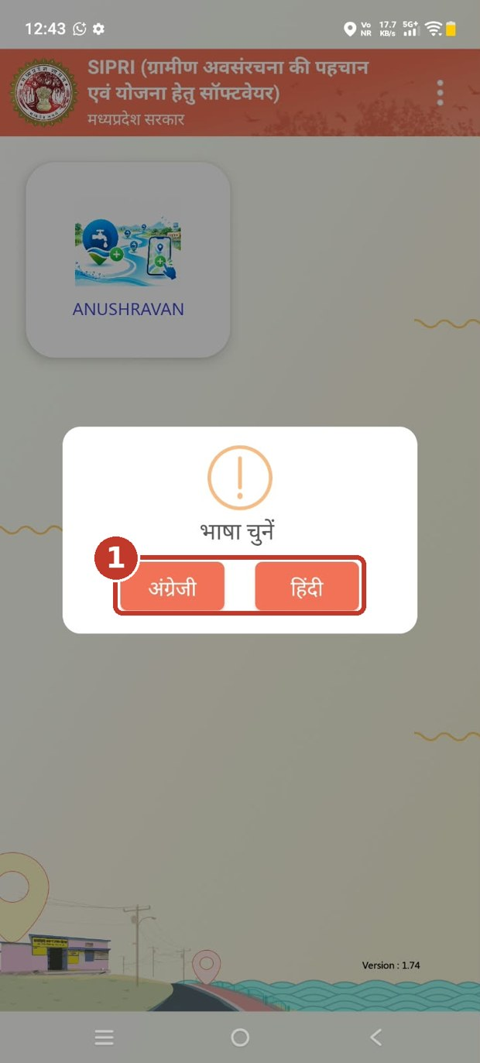  (1) Choose English (अंग्रेज़ी) or Hindi (हिंदी)

5. GP Login: Raise a New RFI / GP लॉगिन: नया RFI दर्ज करें
Step 1: Create a new RFI
- On the ANUSHRAVAN screen, tap Create New RFI. (To see old requests, tap RFI History.)
Step 2: Fill in the form
- Your name, designation, district, block and Gram Panchayat appear automatically.
- Select the Village, Scheme / Head, Work Category and Work Sub-Category.
- Enter the Work Location (Address).
- Scroll down and enter the Date of Inspection and add the geo-tagged photos.
- All fields marked with * are required.

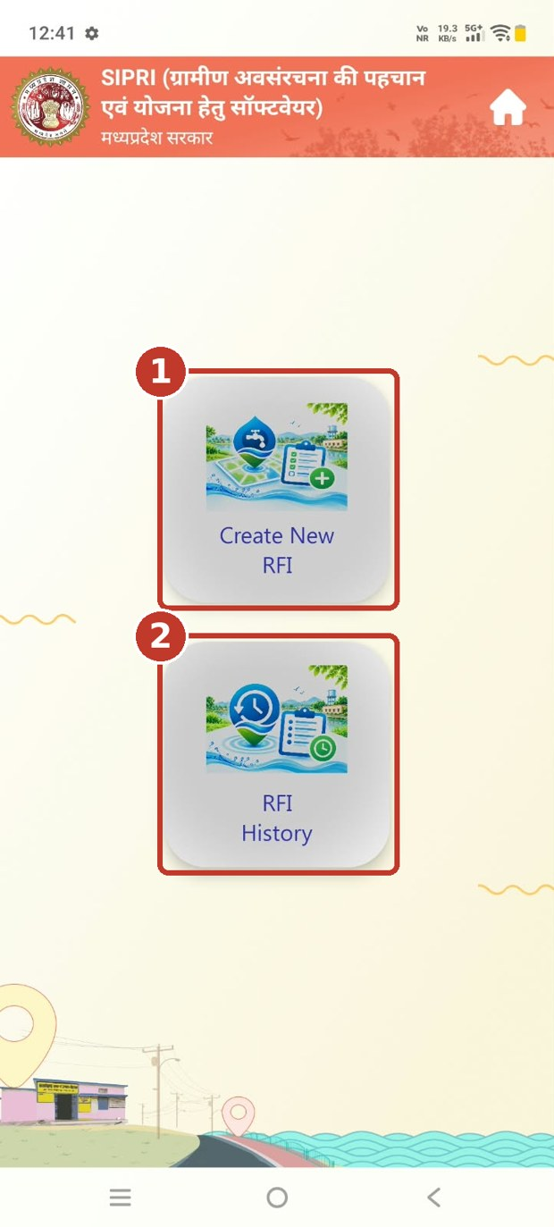  (1) Tap Create New RFI  (2) Tap RFI History to see old requests | 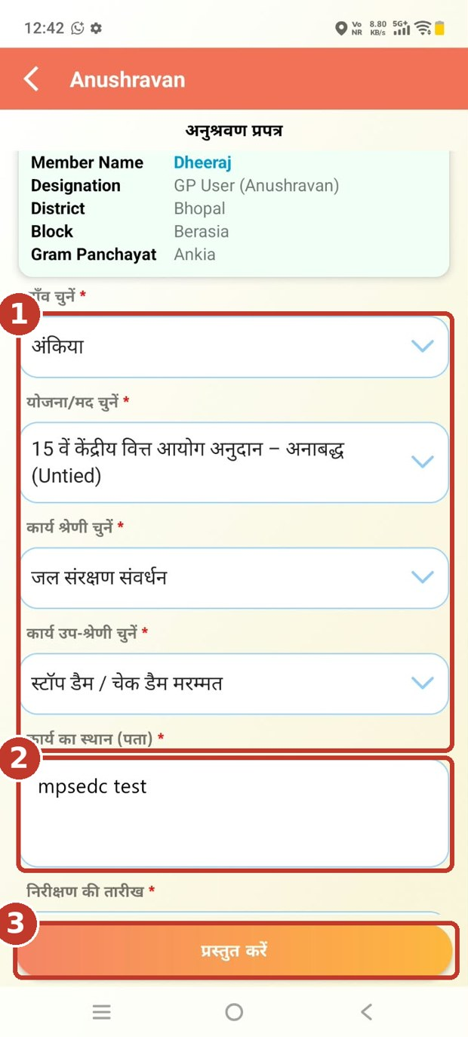  (1) Select village, scheme, category and sub-category  (2) Enter the work address  (3) Tap Submit (प्रस्तुत करें) after all fields are filled
Step 3: Capture the photos
- Tap Capture Image and take a geo-tagged photo of the work site.
- You can add 1 to 5 photos (shown as "Captured 1/5"). Tap ✕ on a photo to remove it.
Step 4: Save the photos
- Tap Save Photos.
- The message "PDF created successfully!" appears. Tap ठीक है (OK). You return to the form.

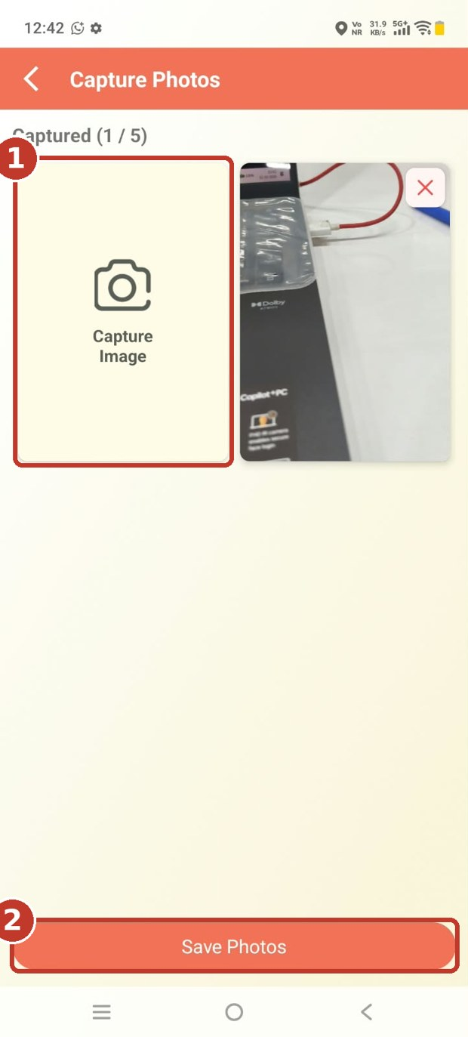  (1) Tap Capture Image  (2) Tap Save Photos | 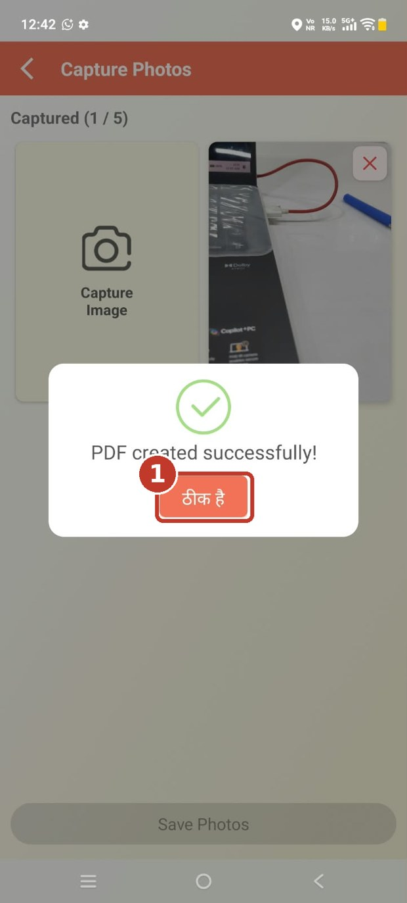  (1) Tap ठीक है (OK)
Step 5: Submit the RFI
- Tap प्रस्तुत करें (Submit).
- A message asks "Are you sure you want to submit the form?". Tap हाँ (Yes). Tap नहीं (No) to go back.
Step 6: RFI raised
- The message "RFI request raised successfully" appears. Tap ठीक है (OK).
- The RFI is now Pending and goes to the Sub Engineer.

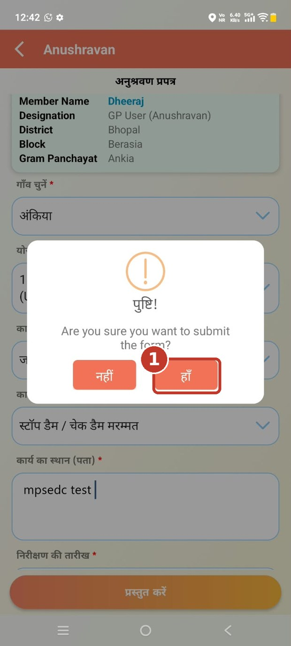  (1) Tap हाँ (Yes) to submit | 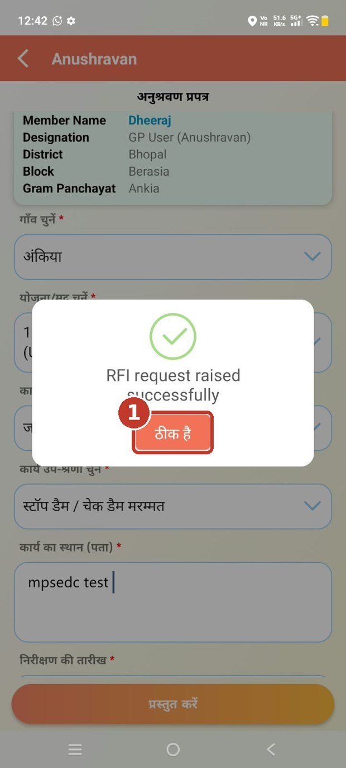  (1) Tap ठीक है (OK)

6. GP Login: View RFI History / GP लॉगिन: RFI इतिहास देखें
Step 1: Open RFI History
- On the ANUSHRAVAN screen, tap RFI History.
Step 2: Check the RFI
- Each card shows the RFI Id, status, date, category, sub-category, scheme, district, block, GP, village and address.
- The Status shows Pending, Approved or Rejected.
- The card also shows the location, inspection date and map.
Step 3: View the photos
- Tap View GP Field Photos to see the photos you uploaded.
- After the Sub Engineer inspects the site, the Sub Engineer photo and remark are also shown on the card.

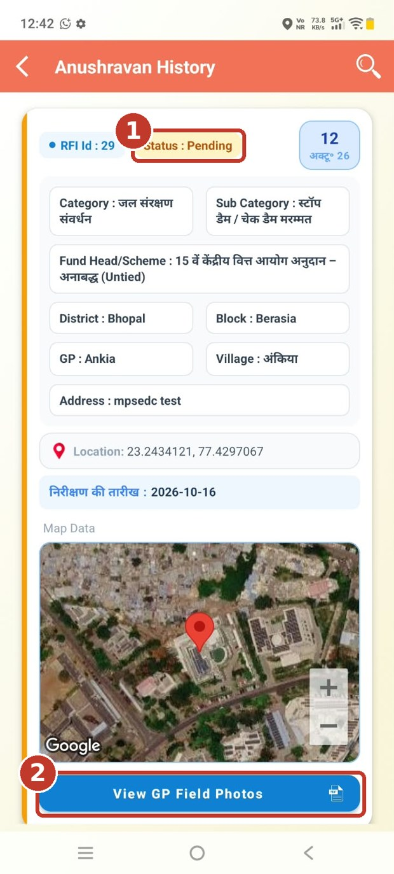  (1) RFI status  (2) Tap View GP Field Photos | 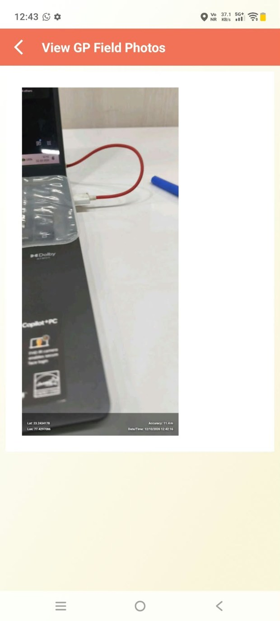  GP field photo

7. Sub Engineer (SE) Login: Inspect and Accept / Reject RFI / SE लॉगिन: RFI का निरीक्षण और स्वीकृत / अस्वीकृत करें
Step 1: Log in and open the module
- Log in with your mobile number and OTP (see Section 3).
- On the dashboard, tap ANUSHRAVAN. The list of pending RFIs opens.
Step 2: Select the RFI
- Tap Verify RFI on the RFI you want to inspect.

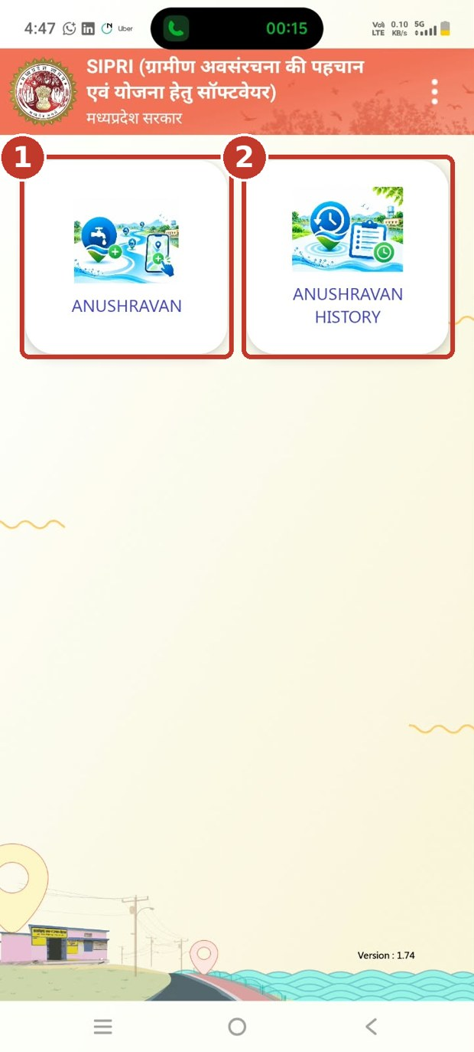  (1) Tap ANUSHRAVAN to inspect RFIs  (2) ANUSHRAVAN HISTORY shows your old RFIs | 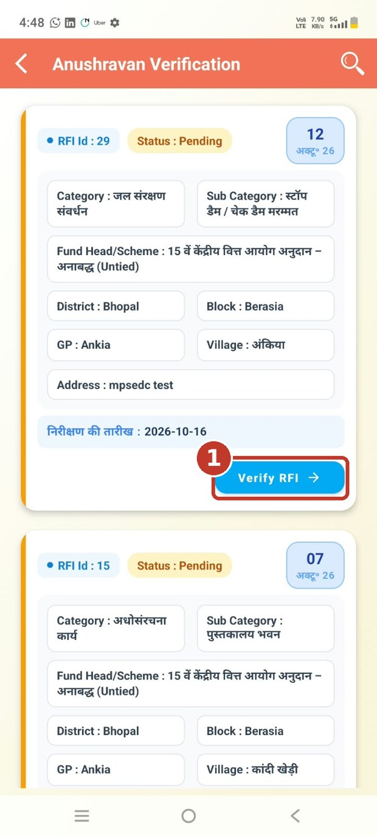  (1) Tap Verify RFI
Step 3: Check the site details
- Read the RFI Id, date, category, sub-category, scheme, district, block, GP, village, address and site location.
- Tap मौजूदा फ़ोटो देखें (View existing photos) to see the photos uploaded by the GP.
Step 4: Go to the site and choose the decision
- The site map shows a 50 m boundary and your Distance from site. Make sure you are within 50 m of the site.
- Under the inspection form, choose स्वीकृत करें (Approve) or अस्वीकृत करें (Reject).
- Enter the Remark (टिप्पणी). It is required.

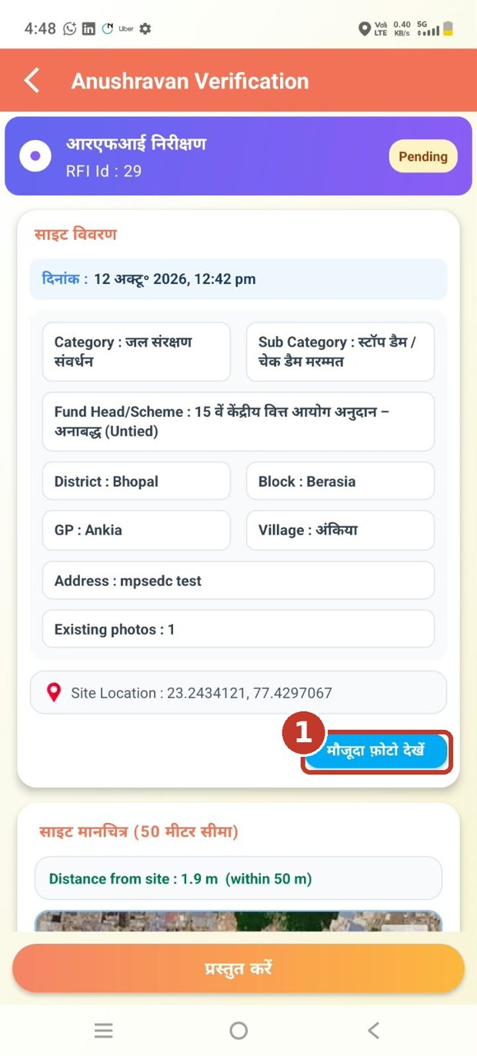  (1) Tap मौजूदा फ़ोटो देखें to view GP photos | 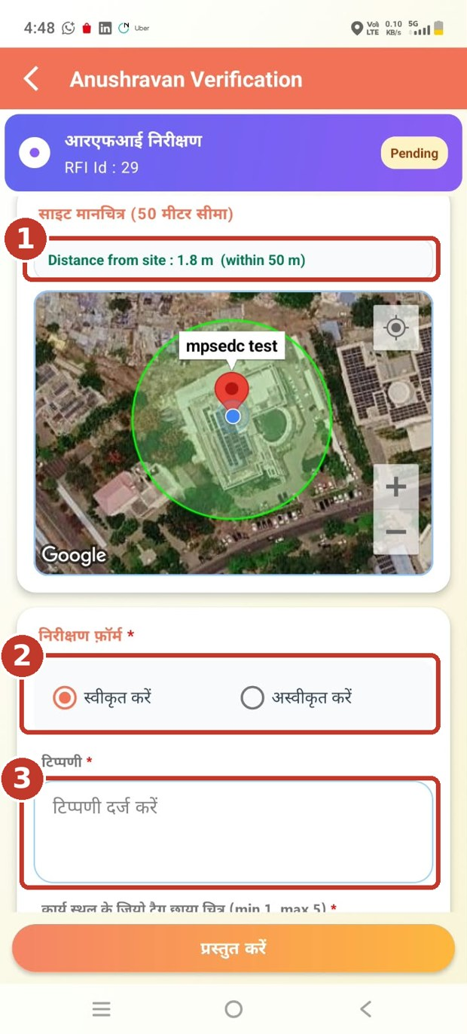  (1) Check the distance from site  (2) Choose Approve or Reject  (3) Enter the remark
Step 5: Capture the verification photos
- Scroll down, tap the photo field, then tap Capture Image and take a geo-tagged photo of the site.
- You can add 1 to 5 photos.
Step 6: Save the photos
- Tap Save Photos.
- The message "PDF created successfully!" appears. Tap ठीक है (OK).

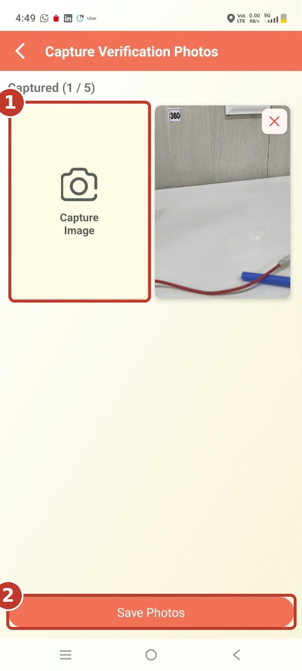  (1) Tap Capture Image  (2) Tap Save Photos | 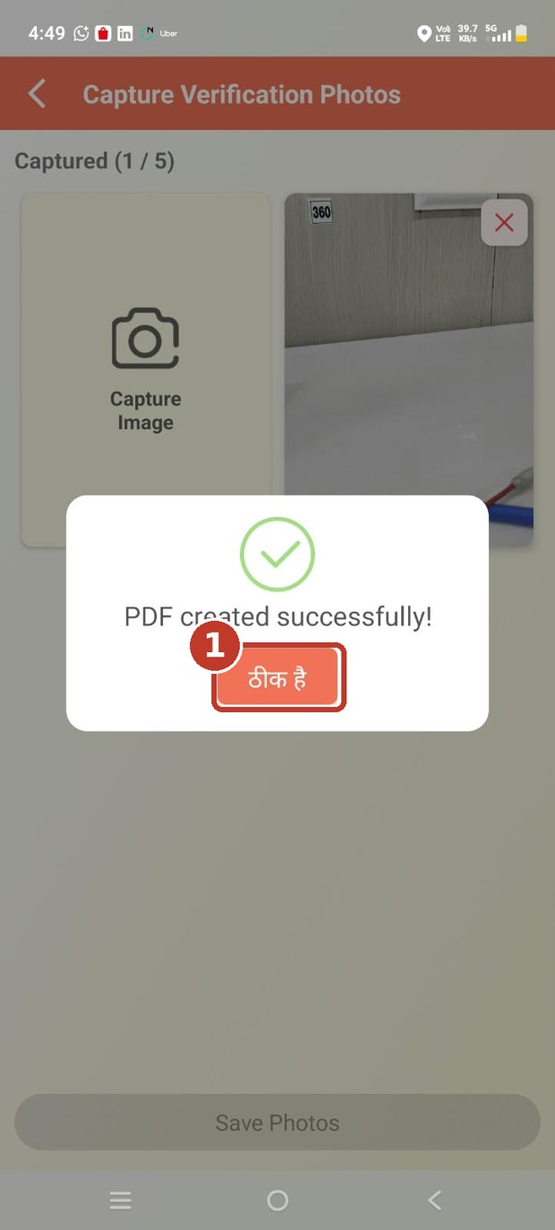  (1) Tap ठीक है (OK)
Step 7: Submit the decision
- The photo file is attached to the form. Check the decision and remark, then tap प्रस्तुत करें (Submit).
- A message asks "Are you sure you want to submit this verification?". Tap हाँ (Yes).
Step 8: Inspection done
- The message "RFI submitted successfully by SE" appears. Tap ठीक है (OK).
- The RFI status changes to Approved or Rejected.

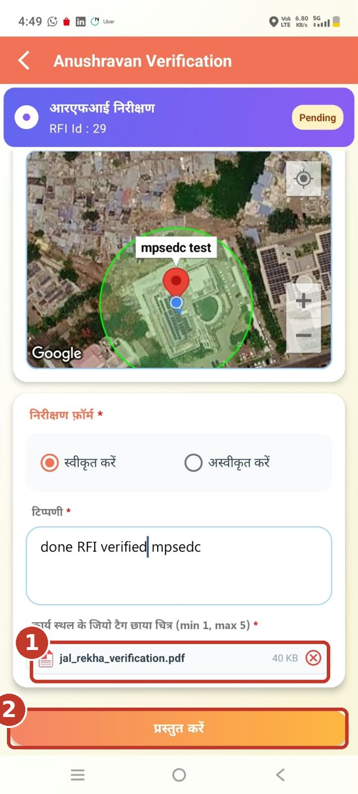  (1) Photo file is attached  (2) Tap Submit | 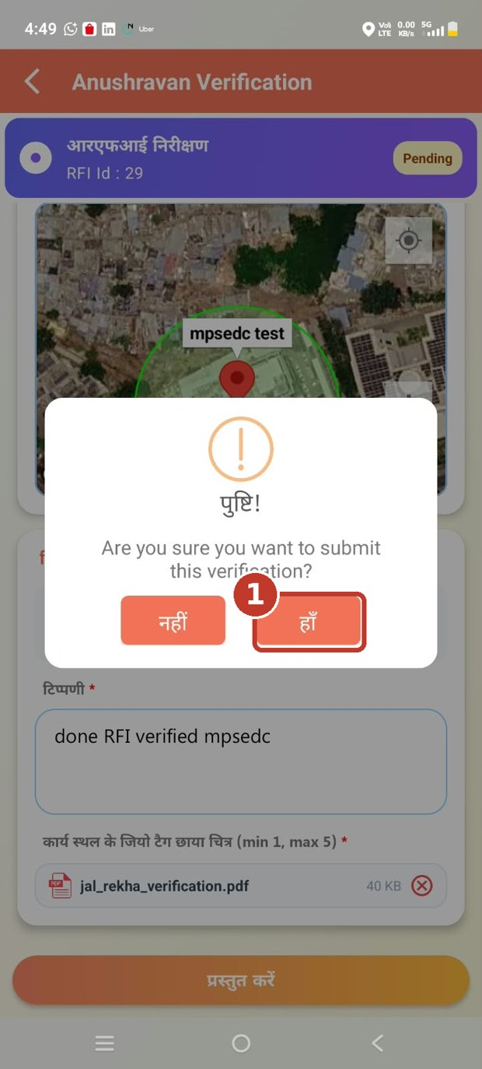  (1) Tap हाँ (Yes) | 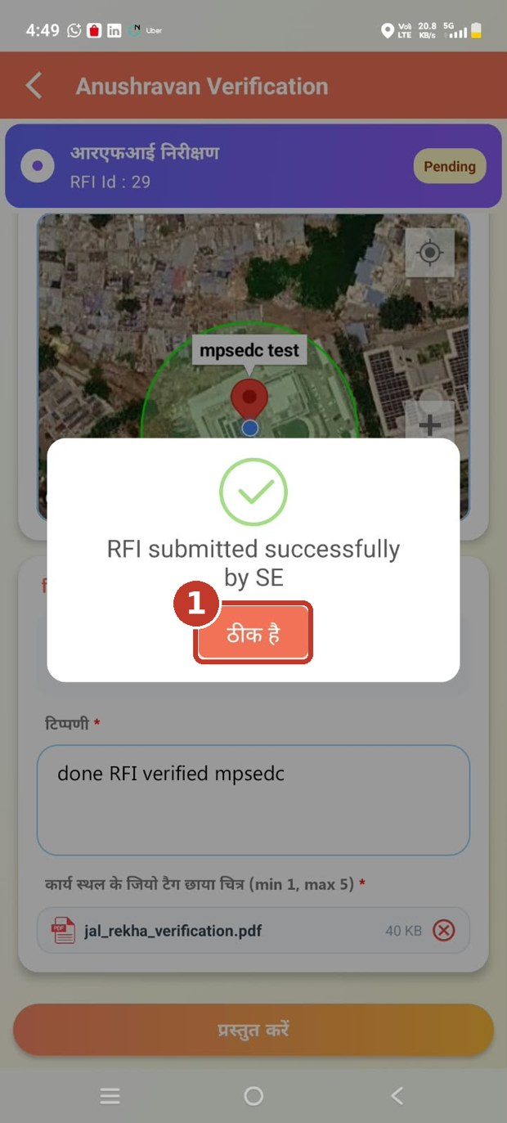  (1) Tap ठीक है (OK)

8. Sub Engineer (SE) Login: View RFI History / SE लॉगिन: RFI इतिहास देखें
Step 1: Open the history
- On the dashboard, tap ANUSHRAVAN HISTORY.
Step 2: Check the RFI
- Each card shows the RFI Id and the Status (Approved or Rejected), with the site details and map.
Step 3: See photos and remark
- Tap View GP Field Photos to see the GP photos.
- Scroll down. Tap Sub Engineer (SE) Field Photo to see your inspection photo. Your remark is shown below the buttons.

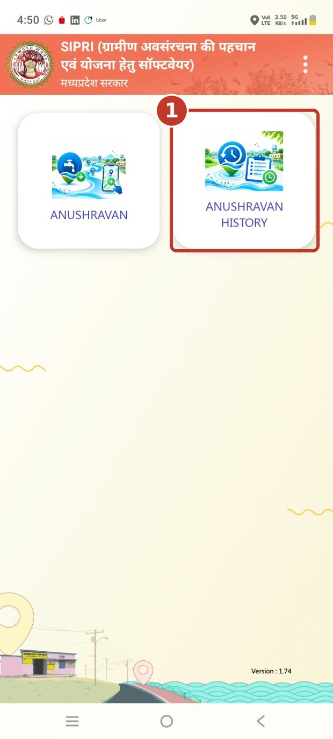  (1) Tap ANUSHRAVAN HISTORY | 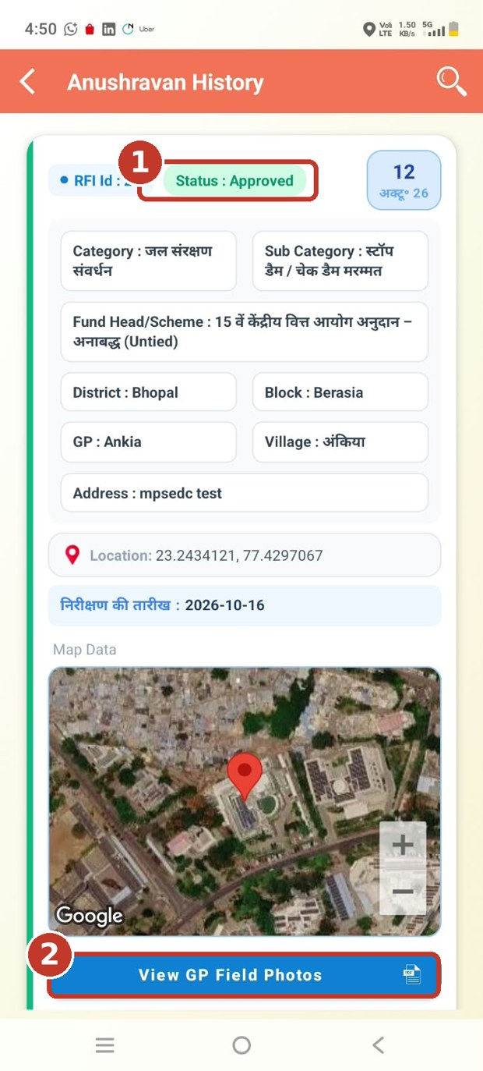  (1) RFI status  (2) Tap View GP Field Photos | 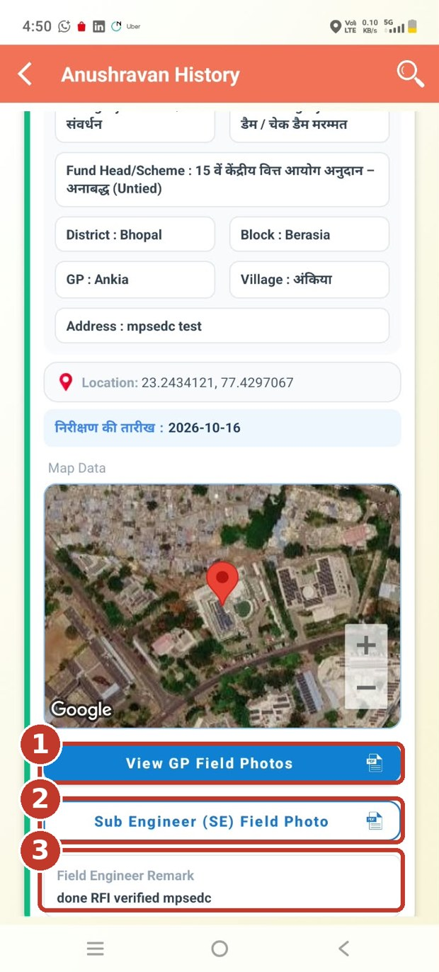  (1) GP photos  (2) Sub Engineer (SE) photo  (3) Remark of the Sub Engineer
Photos
The photos open inside the app. Tap the back arrow (←) to return to the history.

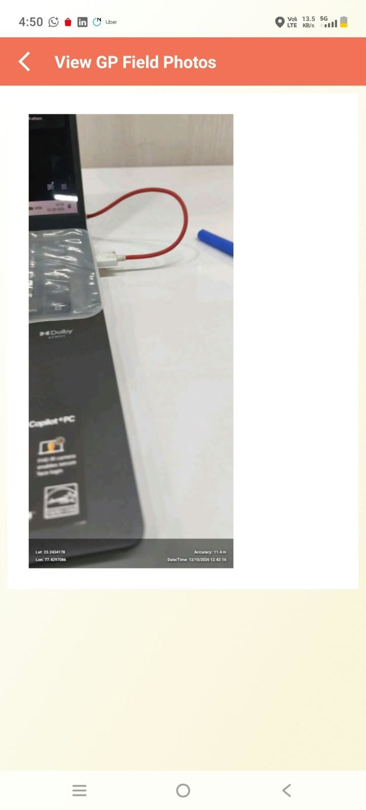  GP field photo | 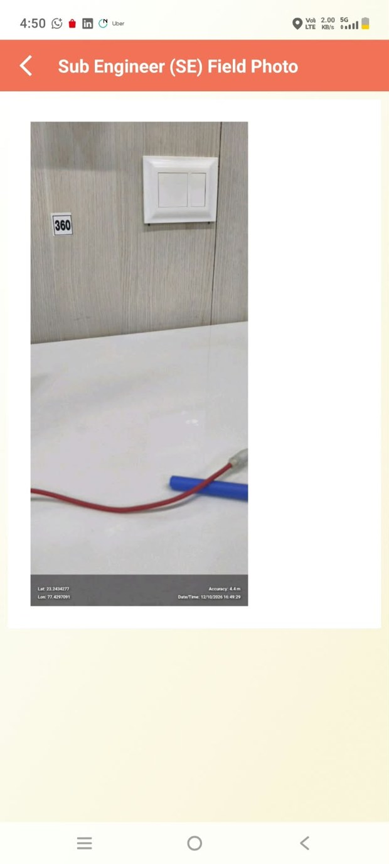  Sub Engineer (SE) field photo

9. SE User Management: Create and Edit Users / SE उपयोगकर्ता प्रबंधन: उपयोगकर्ता बनाना और संपादित करना
The District Admin creates and edits the users on the SIPRI web portal. Use the same steps to edit an existing user.
Step 1: Log in
- Open https://sipri.mp.gov.in/sipri/login and log in with the District Admin login credentials.
Step 2: Open User Management
- On the Home Page, select the User Management tab.
Step 3: Open the User Creation Form
- Select the user category for the user creation form.
Step 4: Select the category
- On the User Creation page, open the User Category dropdown and select Anushravan GP.
- Fill in the required fields marked with * (User Name, Email ID, Mobile Number, Department, Sub-Department, Block, Panchayat and Status).
- Click Save. Click Reset to clear the form.
Edit an existing user
- Log in as District Admin and open the User Management tab.
- Select the existing user, set the User Category to Anushravan, and click Save.
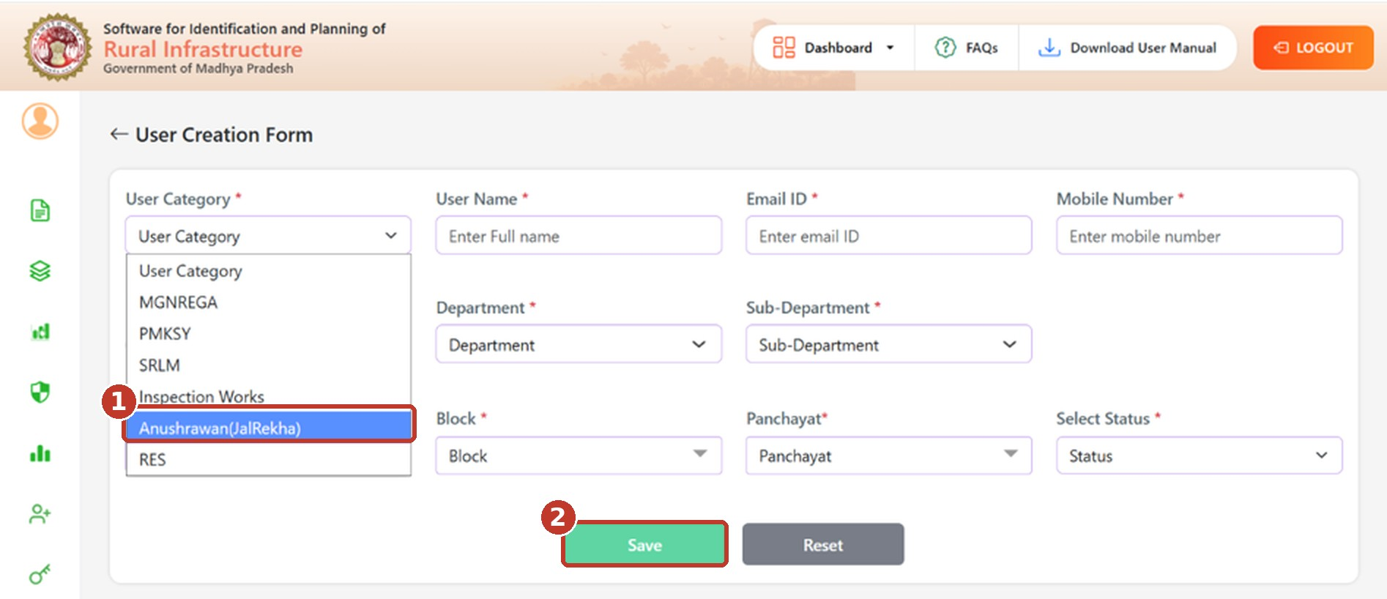
(1) Select Anushravan in the User Category dropdown (2) Click Save

10. Web Portal: Anushravan GP Report / वेब पोर्टल: अनुश्रवण GP रिपोर्ट
Step 1: Log in
- Open the SIPRI web portal in your browser: https://sipri.mp.gov.in/sipri/login
- GP users: select the MP Darpan Login button and log in with your Panchayat Darpan credentials.
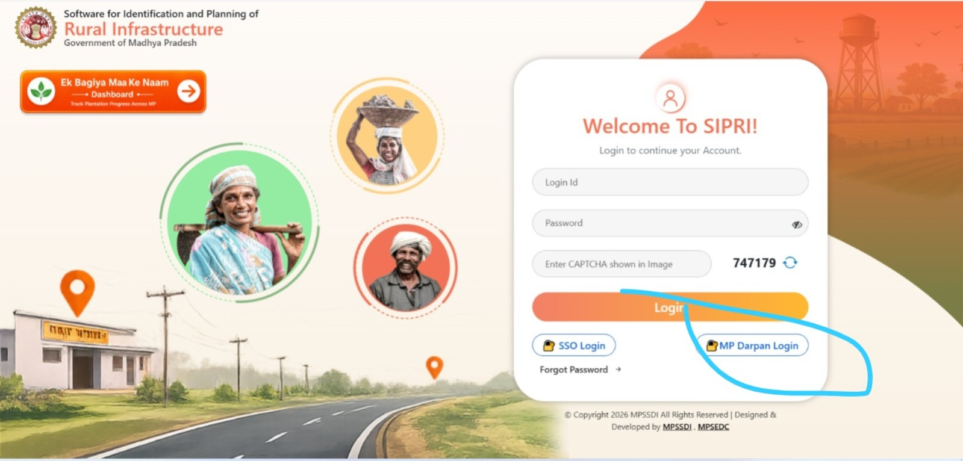
Click the MP Darpan Login button (marked in blue). GP users do this one-time login before using the mobile app.
- Then enter your Login Id and Password. Enter the CAPTCHA shown on the screen and click Login.
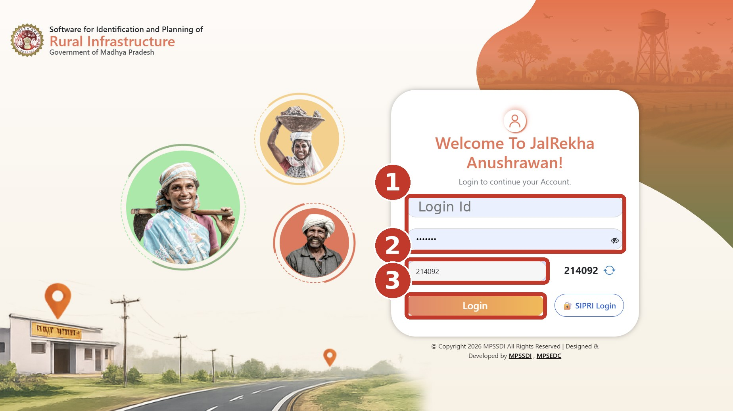
(1) Enter Login Id and Password (2) Enter the CAPTCHA (3) Click Login
Step 2: Open the report
- After login, the Anushravan GP Report opens. You can also open it from the menu on the left.
Step 3: Use the report
- Type a keyword in the search box to find an RFI.
- Click Download to download the report.
- Click the file icon under GP Field Image or SE Field Image to open the photos.
- Use Previous and Next below the table to change the page. Click LOGOUT (top right) when you finish.
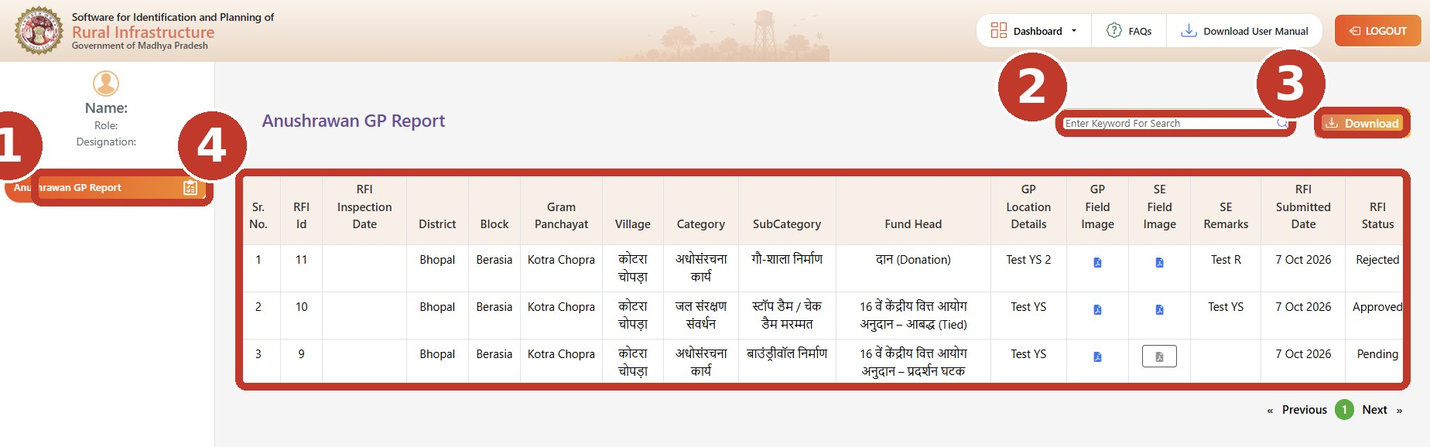
(1) Report menu (2) Search (3) Download (4) RFI table
Report columns
Column | Meaning
Sr. No. / RFI Id | Serial number and the Id of the RFI.
RFI Inspection Date | Date of inspection given by the GP user.
District, Block, Gram Panchayat, Village | Location of the work site.
Category, SubCategory | Work category and sub-category selected by the GP.
Fund Head | Scheme / head selected by the GP.
GP Location Details | Work address entered by the GP.
GP Field Image | Photo file uploaded by the GP.
SE Field Image | Photo file uploaded by the Sub Engineer. A grey icon means the inspection is not done yet.
SE Remarks | Remark entered by the Sub Engineer.
RFI Submitted Date | Date on which the Sub Engineer submitted the inspection.
RFI Status | Pending, Approved or Rejected.

11. Important Notes / महत्वपूर्ण बिंदु
- GP User: The GP user must log in to the SIPRI web portal once using their Panchayat Darpan login credentials. After completing this one-time login, they will be able to log in to the SIPRI mobile app and submit RFI requests from their mobile device.
- SE Users: The Anushravan GP User category must be selected at the district level on the SIPRI portal.
- Web Login SIPRI Portal: https://sipri.mp.gov.in/sipri/login
- Keep the location (GPS) ON in the mobile app. The app uses it for geo-tagged photos and for the distance from the site.
- Use the mobile number registered for your login.
- Fields marked with * are required.
- Add 1 to 5 geo-tagged photos for every RFI and every inspection.
- Tap Save Photos after capturing the photos. Wait for "PDF created successfully!" before you submit.
- The Sub Engineer must inspect the site and Accept or Reject the RFI. The status changes from Pending after the decision.

